# **Lab 4: Advanced Prompt Engineering – Zero-shot, One-shot, and Few-shot Techniques**

# Assignment 4.1

**Name:CHADA SATHWIKA**

**HTNO:2403a51334**

**BTNO:24BTCAICSB14**

**TASK1:**

**Prompt:**write a python function that checks whether a given year is palindrome or not

**CODE and OUTPUT:**

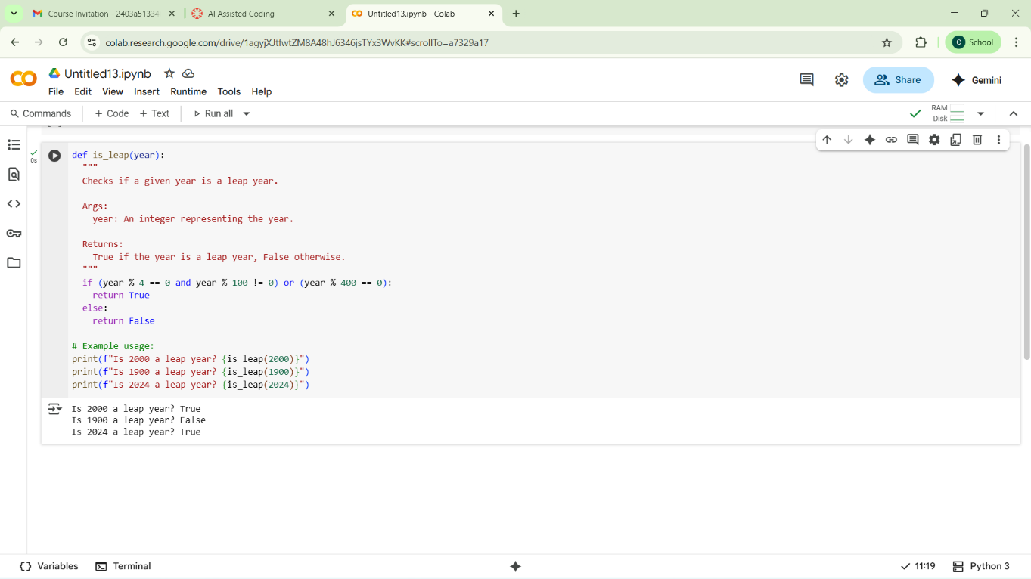

**Code explanation:**

Function Purpose

def is_leap(year):

This defines a function named is_leap that takes one argument: year (an integer).

📘 Docstring

""" Checks if a given year is a leap year. Args: year: An integer representing the year. Returns: True if the year is a leap year, False otherwise.

Leap Year Logic

if (year % 4 == 0 and year % 100 != 0) or (year % 400 == 0): return True else: return False

This is the core logic:

* A year is a leap year if:
* It’s divisible by 4 and not divisible by 100, or
* It’s divisible by 400

This handles exceptions like:

* 1900: divisible by 4 and 100, but not 400 → not a leap year
* 2000: divisible by 400 → leap year
* **• 2024**: divisible by 4 and not 100 → **leap year**
* 🧪 Example Usage
* print(f"Is 2000 a leap year? {is_leap(2000)}") print(f"Is 1900 a leap year? {is_leap(1900)}") print(f"Is 2024 a leap year? {is_leap(2024)}")
* These lines test the function with different years and print the result using f-strings for clean format

Observations

**TASK 2:**

**Prompt:** write a python function that converts centimeters into inches input 10cm output 3.937

**CODE and OUTPUT**

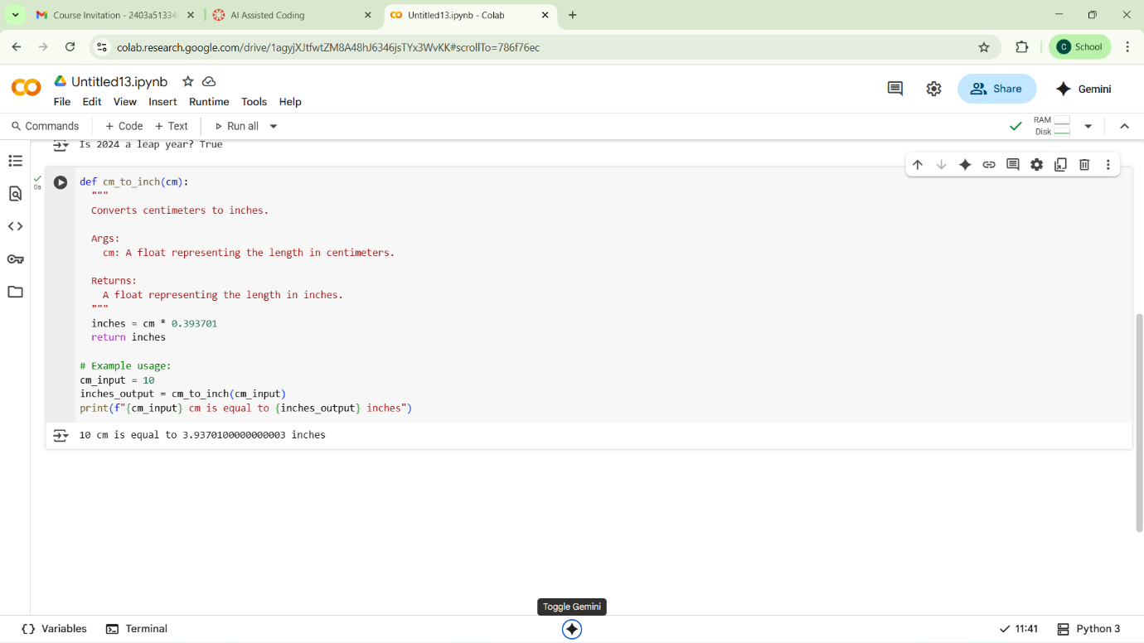

**observation:**

this Python function cm_to_inch(cm) converts a length from centimeters to inches using the conversion factor 0.393701. It takes a numeric input cm, multiplies it by the factor, and returns the result. The function is then tested with 10 cm, which outputs approximately 3.94 inches. This is a simple example of unit conversion using basic arithmetic. It's useful for quick calculations or integrating into larger measurement tools.

**Task3:**

**Prompt:** write a python function that formats full name as a first and last Input: "John Smith" → Output: "Smith, John" Input: "Alice Johnson" → Output: "Johnson, Alice" Input: "Michael Jordan" → Output: "Jordan, Michael"

**CODE and OUTPUT:** 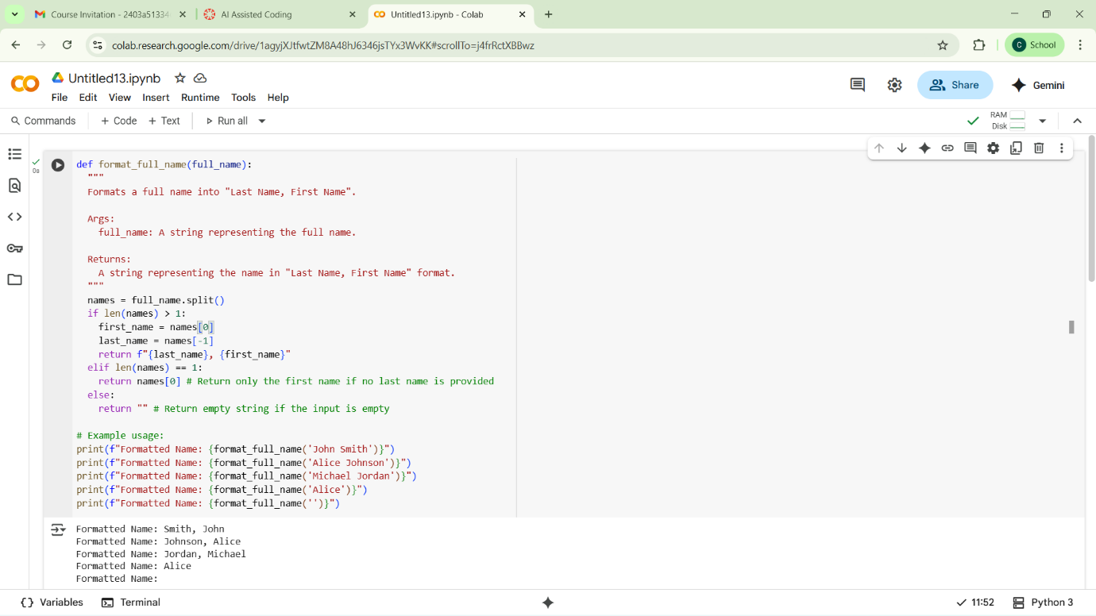

**OBSERVATION:** This Python function format_full_name(full_name) reformats a name string into “Last Name, First Name” format. It splits the input into words and checks how many parts there are. If there are multiple names, it assumes the first is the first name and the last is the last name, then rearranges them. If there's only one name, it returns it unchanged. If the input is empty, it returns an empty string.

**TASK4:**

**Zero shot:**

**Prompt:**write a python function that counts the vowels in a given string

**CODE and OUTPUT:**

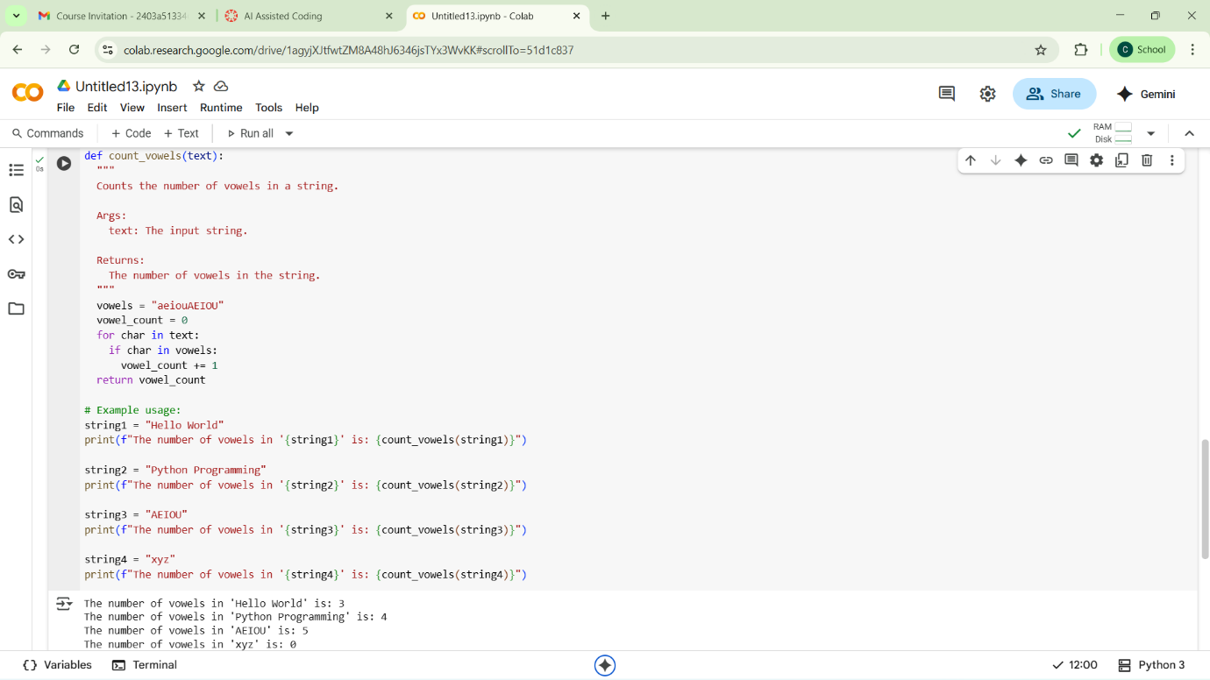

**ONE SHOT:**

**Prompt**: write a python function that counts number of vowels in a string input:sathwika output:3

**Code and output:**

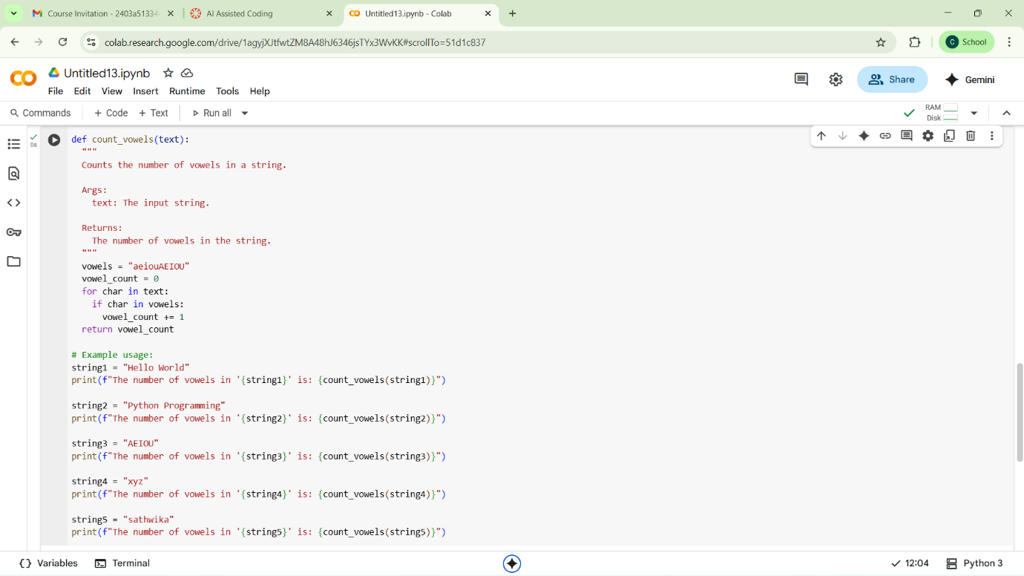

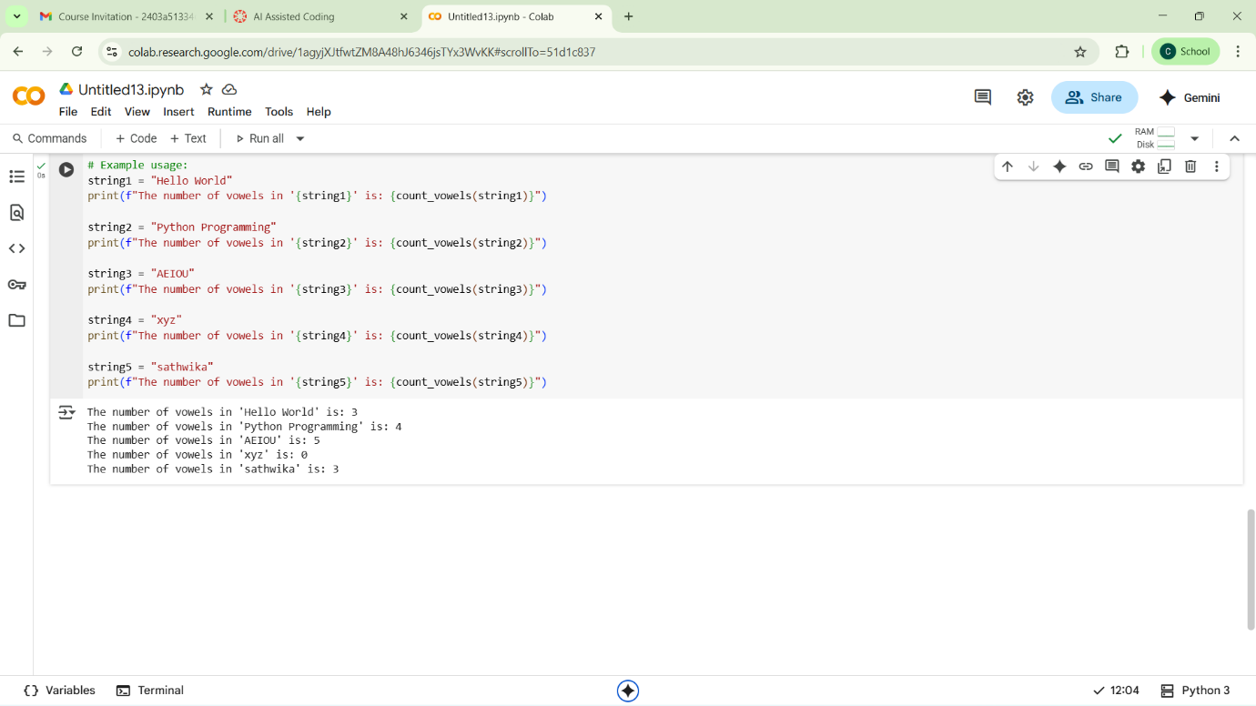

**COMPARISION TABLE**

| Aspect | Zero-Shot | Few-Shot |
| --- | --- | --- |
| Definition | Task described with no examples | Task + related examples provided |
| Clarity Needed | Requires a clear, self-contained prompt | Can be more flexible with natural guidance from examples |
| Performance | May vary based on task complexity | Typically more consistent and structured |
| Control | Less control over code style or method | More control over structure and logic |
| Use Case Fit | Simple or familiar tasks | Tasks with desired patterns or when ambiguity exists |

**TASK5:**

**Prompt:** write a function that reads a .txt file and returns the number of lines. Examples: Input: "sample1.txt" → Output: 15 Input: "notes.txt" → Output: 42 Input: "data.txt" → Output: 8 Now write a function that performs this task for any .txt file:

**CODE AND OUTPUT:**

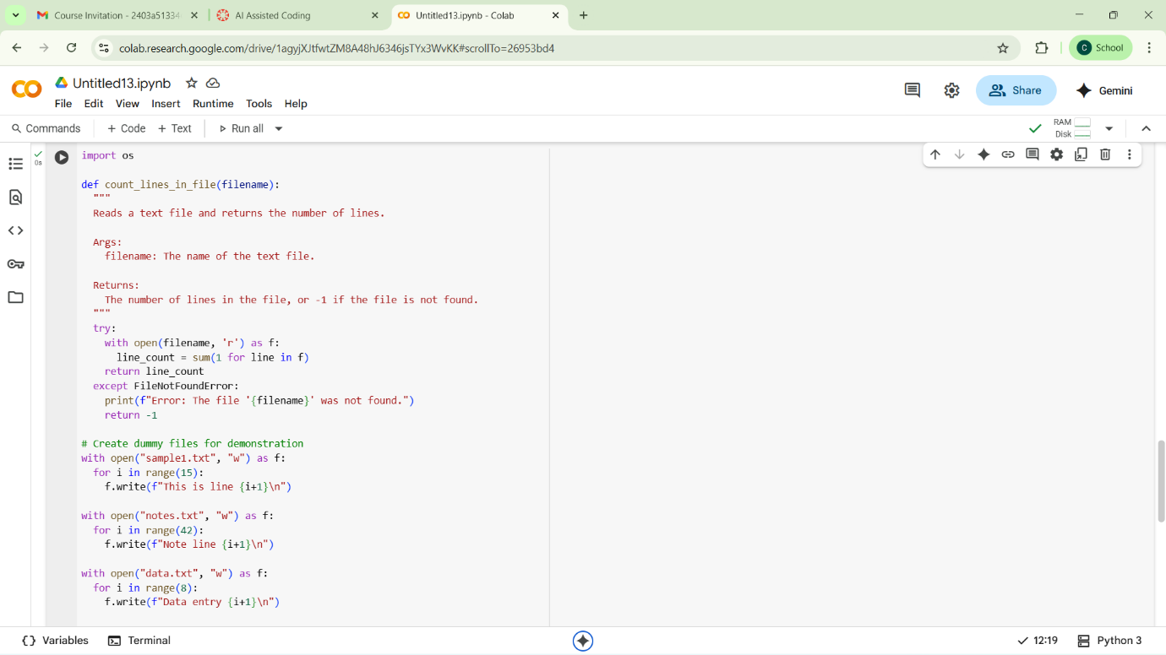

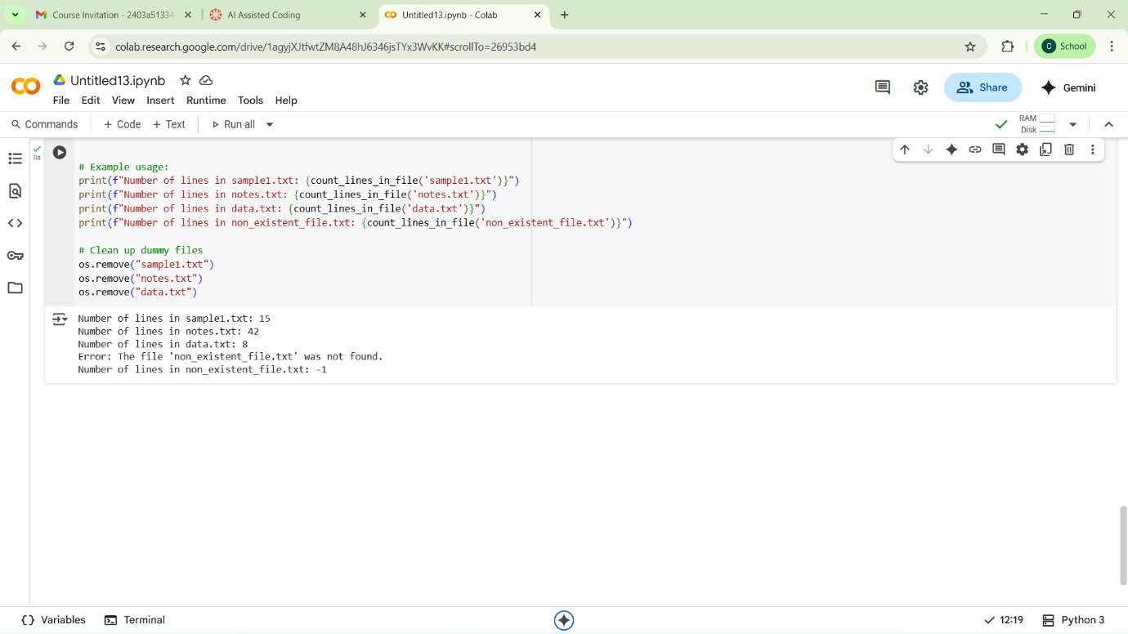

**Observation**

This code defines a Python function count_lines_in_file that takes a filename as input. It attempts to open and read the file, counting the number of lines within it. If the file is found, it returns the line count; otherwise, it prints an error message and returns -1. The code also includes examples of how to use the function with existing and non-existent files, and it cleans up the dummy files created for the demonstration.